OUTLOOK ADD-INS

Prerequisites

* Node version 14.0.0
* An app should be registered in Azure portal with following permissions
* 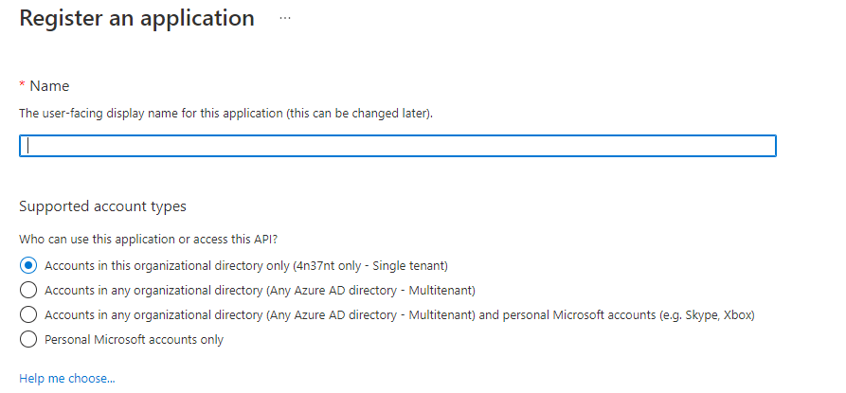

Select multi tenant option (option 2)

* Create Client Secret 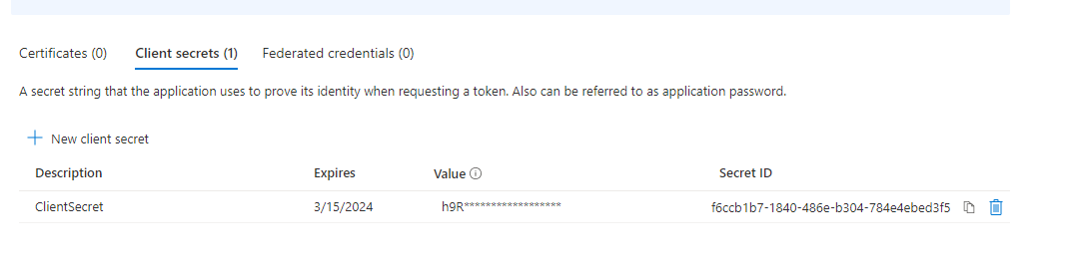

|  |  |  |  |  |  |
| --- | --- | --- | --- | --- | --- |
| Microsoft Graph (33) |  |  |  |  |  |
| Directory.Read.All | Application | Read directory data | Yes | Granted for 4n37nt |  |
| Directory.ReadWrite.All | Application | Read and write directory data | Yes | Granted for 4n37nt |  |
| Files.ReadWrite.All | Application | Read and write files in all site collections | Yes | Granted for 4n37nt |  |
| Group.Create | Application | Create groups | Yes | Granted for 4n37nt |  |
| Group.Read.All | Delegated | Read all groups | Yes | Granted for 4n37nt |  |
| Group.ReadWrite.All | Delegated | Read and write all groups | Yes | Granted for 4n37nt |  |
| Group.ReadWrite.All | Application | Read and write all groups | Yes | Granted for 4n37nt |  |
| GroupMember.ReadWrite.All | Application | Read and write all group memberships | Yes | Granted for 4n37nt |  |
| Mail.Read | Delegated | Read user mail | No | Granted for 4n37nt |  |
| Mail.Read.Shared | Delegated | Read user and shared mail | No | Granted for 4n37nt |  |
| Mail.ReadBasic | Delegated | Read user basic mail | No | Granted for 4n37nt |  |
| Mail.ReadWrite | Delegated | Read and write access to user mail | No | Granted for 4n37nt |  |
| Mail.ReadWrite.Shared | Delegated | Read and write user and shared mail | No | Granted for 4n37nt |  |
| Mail.Send | Delegated | Send mail as a user | No | Granted for 4n37nt |  |
| Mail.Send.Shared | Delegated | Send mail on behalf of others | No | Granted for 4n37nt |  |
| MailboxSettings.Read | Delegated | Read user mailbox settings | No | Granted for 4n37nt |  |
| MailboxSettings.ReadWrite | Delegated | Read and write user mailbox settings | No | Granted for 4n37nt |  |
| Notes.Read.All | Application | Read all OneNote notebooks | Yes | Granted for 4n37nt |  |
| Notes.ReadWrite.All | Application | Read and write all OneNote notebooks | Yes | Granted for 4n37nt |  |
| Sites.ReadWrite.All | Application | Read and write items in all site collections | Yes | Granted for 4n37nt |  |
| Tasks.Read | Delegated | Read user's tasks and task lists | No | Granted for 4n37nt |  |
| Tasks.Read.All | Application | Read all users’ tasks and tasklist | Yes | Granted for 4n37nt |  |
| Tasks.ReadWrite | Delegated | Create, read, update, and delete user’s tasks and task lists | No | Granted for 4n37nt |  |
| Tasks.ReadWrite.All | Application | Read and write all users’ tasks and tasklists | Yes | Granted for 4n37nt |  |
| TeamMember.ReadWrite.All | Application | Add and remove members from all teams | Yes | Granted for 4n37nt |  |
| TeamsTab.Create | Application | Create tabs in Microsoft Teams. | Yes | Granted for 4n37nt |  |
| TeamsTab.Read.All | Application | Read tabs in Microsoft Teams. | Yes | Granted for 4n37nt |  |
| TeamsTab.ReadWrite.All | Application | Read and write tabs in Microsoft Teams. | Yes | Granted for 4n37nt |  |
| TeamsTab.ReadWriteForTeam.All | Application | Allow the Teams app to manage all tabs for all teams | Yes | Granted for 4n37nt |  |
| User.Invite.All | Application | Invite guest users to the organization | Yes | Granted for 4n37nt |  |
| User.Read | Delegated | Sign in and read user profile | No | Granted for 4n37nt |  |
| User.Read.All | Application | Read all users' full profiles | Yes | Granted for 4n37nt |  |
| User.ReadWrite.All | Application | Read and write all users' full profiles | Yes | Granted for 4n37nt |  |
| SharePoint (8) |  |  |  |  |  |
| AllSites.FullControl | Delegated | Have full control of all site collections | Yes | Granted for 4n37nt |  |
| AllSites.Manage | Delegated | Read and write items and lists in all site collections | No | Granted for 4n37nt |  |
| AllSites.Read | Delegated | Read items in all site collections | No | Granted for 4n37nt |  |
| AllSites.Write | Delegated | Read and write items in all site collections | No | Granted for 4n37nt |  |
| Sites.FullControl.All | Application | Have full control of all site collections | Yes | Granted for 4n37nt |  |
| Sites.Read.All | Application | Read items in all site collections | Yes | Granted for 4n37nt |  |
| Sites.ReadWrite.All | Application | Read and write items in all site collections | Yes | Granted for 4n37nt |  |
| Sites.Search.All | Delegated | Run search queries as a user | Yes | Granted for 4n37nt |  |

* Storage Account in Azure portal for deployment process

Setup

Configuration.ts

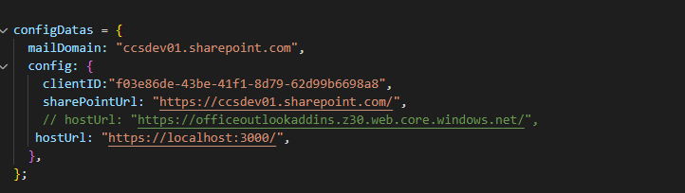

Here

mailDomain =>Tenant domain

ClientID =>ClientID of application registered in azure portal

SharepointUrl => SharePoint URL

HostUrl => Local host URL.

SharepointController.ts

1. Get all the SharePoint sites from our tenant
2. Get all the document libraries
3. Get all the folders in document libraries
4. Saving the metadata to the SharePoint list

GraphController.ts

1.Get all the site details such as siteID, driverID

2. Saving the attachments. There is separate function for

large attachment and small attachment.

App.tsx

1. Setup the render part
2. On page load get all sites from our tenant using function from SharePoint controller.
3. Get all the document library according to the site selected in previous drop down
4. Get all the folders according to the document library selected in previous drop down
5. Load the graph controller functions to save the attachments to the selected SharePoint site
6. Load the SharePoint controller function to save the meta data to SharePoint list

Issues

* Node version was not supported in system

-By installing NVM Node 14.0.0 installed

* Issues with pnp/sp versions

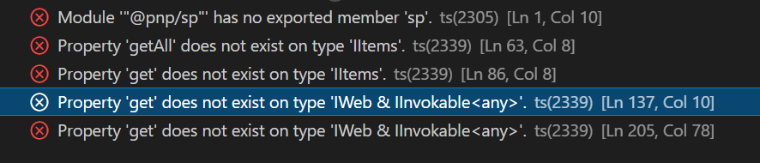

- By installing below mentioned versions

@pnp/spfx-controls-react

@microsoft/microsoft-graph-client": "^3.0.1

@microsoft/microsoft-graph-types": "^2.10.0

@pnp/sp": "^2.11.0

@pnp/spfx-controls-react": "^3.5.0

* Issues with login tokens

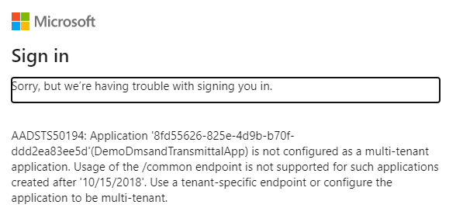

- By giving Graph API permissions and giving Application ID

in configuration file

* Errors with SiteID

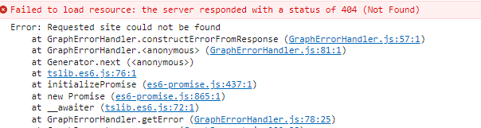

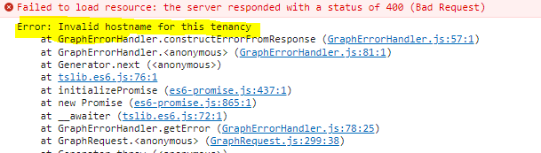

-Made changes in function with the help of Graph Explorer

public GetSiteID(tenantUrl: string, siteName: string): Promise<any> {

return this.client

.api(`https://graph.microsoft.com/v1.0/sites/${tenantUrl}:/sites/${siteName}`) .get().

* Error with DriverID



-Made changes in function with the help of Graph Explorer

public GetAllDriveBySiteID(siteID: string): Promise<any> {

return this.client.api(`https://graph.microsoft.com/v1.0/sites/${siteID}/drives`).version('v1.0') .get()

* Error while adding metadata of attachments into list 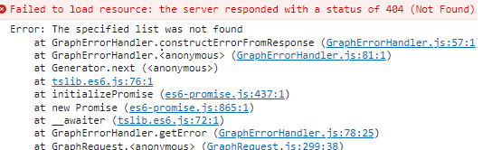
* Can’t Create storage account in Azure

-By using account with subscription issue got resolved

To Run the add-ins locally

1.npm start

2.Open an outlook email select get add ins from more options. And select My add-ins and then by using custom add-ins add the manifest file.

Deployment

1.Installed the Azure extension in VS code

2.Created Storage Account in Azure portal

3. Select and hold (right-click) storage account, choosing Configure Static Website. Changed the index document name from the default index.html to taskpane.html.

4. Select and hold (right-click) your storage again, this time choosing Browse Static Website. Copy the website URL from the browser window that opens.

5.Changed the host URL in configuration.ts to the static web URL

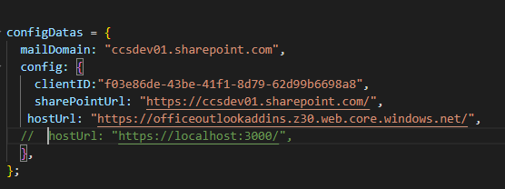

6.Change the ProdUrl in webpack.config.js to the static web URL

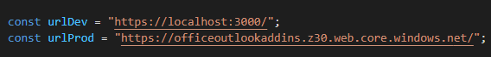

6.Added static website URL to the App registered in azure.

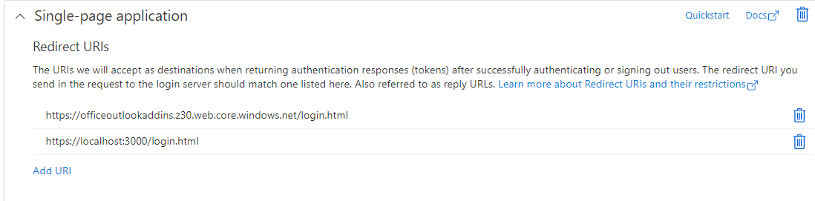

7.Uploaded the custom app to Microsoft 365 Admin center (settings>integrated apps>Upload custom app)

Reference for deployment: [Publish an add-in using Visual Studio Code and Azure - Office Add-ins | Microsoft Docs](https://docs.microsoft.com/en-us/office/dev/add-ins/publish/publish-add-in-vs-code)

How to add Add-Ins in another tenant

1.Create an app in azure portal

2.Give the tenant details in configuration.ts

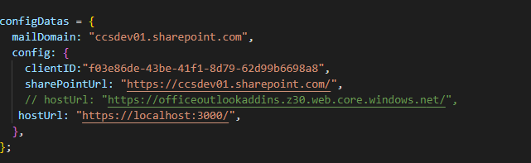

3.Change the list name used in sharepoint controller for fetching the site collection

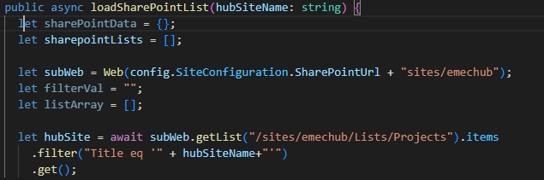

4. Change the list name used in sharepoint controller for saving the meta data of attachments

